1)

1)--Discipline Event with the most number of students

**MySQL**

select a.DisciplineEventCode,a.DisciplineEventDesc, COUNT(distinct b.StudentID) AS Student_Count

from dimDisciplineEventCode a

JOIN

factDiscipline b

ON a.DisciplineEventCodeID = b.DisciplineEventCodeID

JOIN

dimStudent c

ON b.StudentID = c.StudentID

GROUP BY a.DisciplineEventCode,a.DisciplineEventDesc

**OUTPUT**

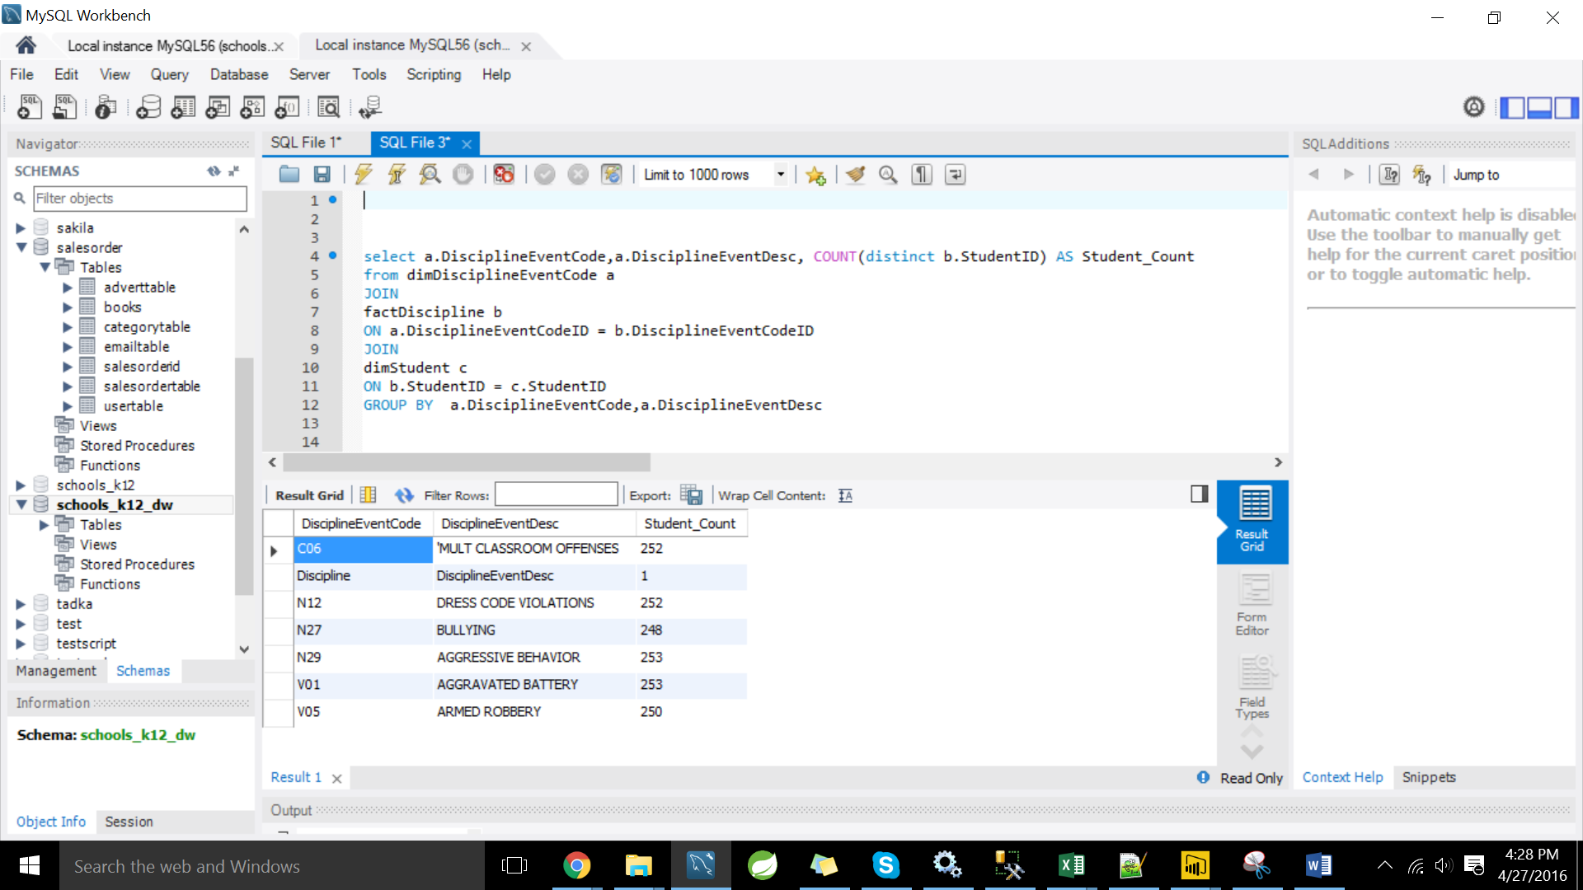

**2)** **Did men have more discipline complains recorded for each discipline Event ?**

Select a.DisciplineEventCode,a.DisciplineEventDesc,c.Gender, COUNT(distinct b.StudentID) AS Student_Count

from dimDisciplineEventCode a

JOIN

factDiscipline b

ON a.DisciplineEventCodeID = b.DisciplineEventCodeID

JOIN

dimStudent c

ON b.StudentID = c.StudentID

GROUP BY a.DisciplineEventCode,a.DisciplineEventDesc,c.Gender

**OUTPUT**

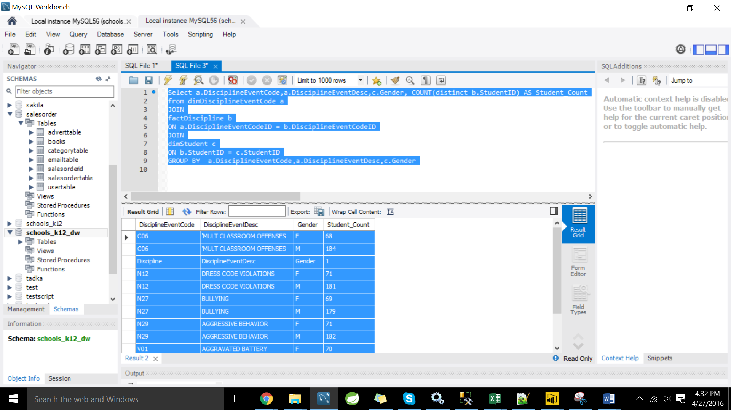

**3) top 5 Student with the highest number of discipline violations**

Select c.StudentID, count(a.DisciplineEventCode) AS Number_Of_Violations

from dimDisciplineEventCode a

JOIN

factDiscipline b

ON a.DisciplineEventCodeID = b.DisciplineEventCodeID

JOIN

dimStudent c

ON b.StudentID = c.StudentID

GROUP BY c.StudentID

ORDER BY count(a.DisciplineEventCode) desc

limit 5;

OUTPUT

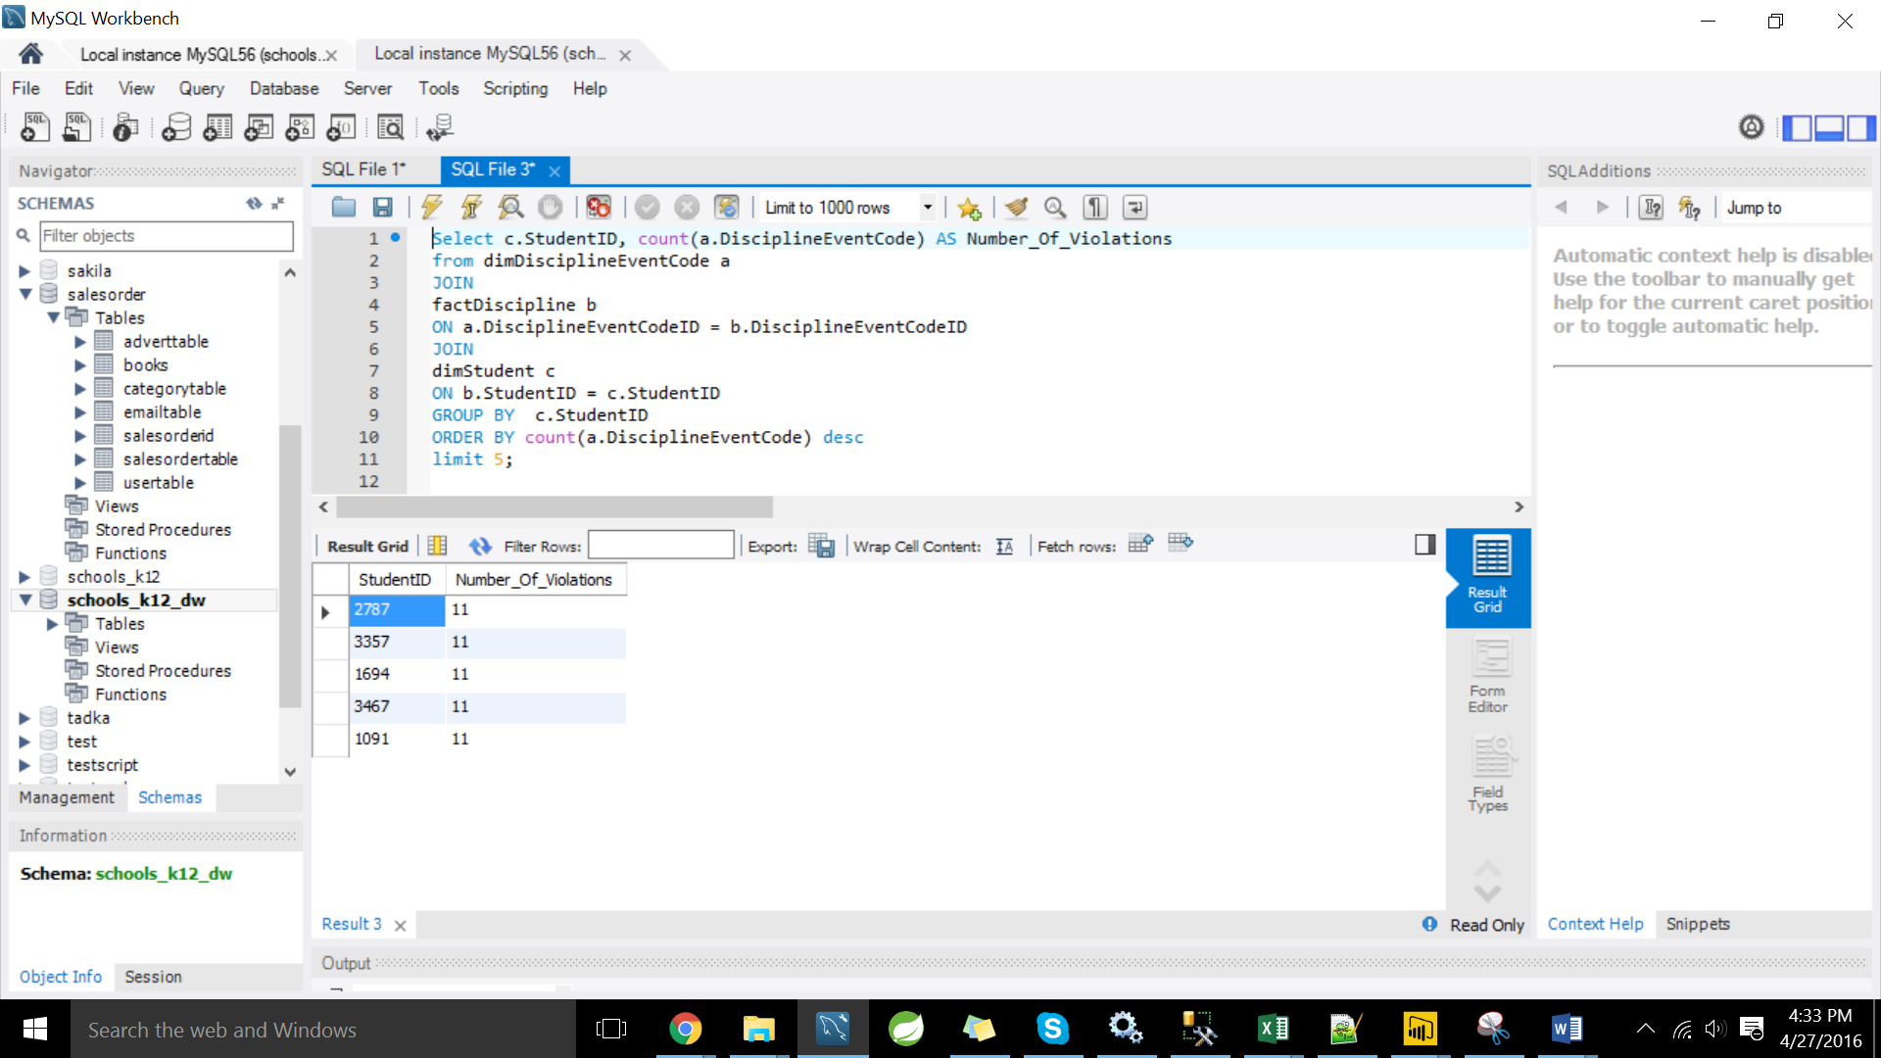

**4) --top staff who have taken action against discipline violations**

select top 1 StaffID, StaffFirstName,StaffLastName, COUNT(b.DisciplineActionCodeID) AS number_of_actions

from dimDisciplineActionCode a

JOIN

factDiscipline b

ON a.DisciplineActionCodeID = b.DisciplineActionCodeID

JOIN

dimStaff c

ON b.ActionStaffID = c.StaffID

GROUP BY StaffID, StaffFirstName,StaffLastName

**OUTPUT**

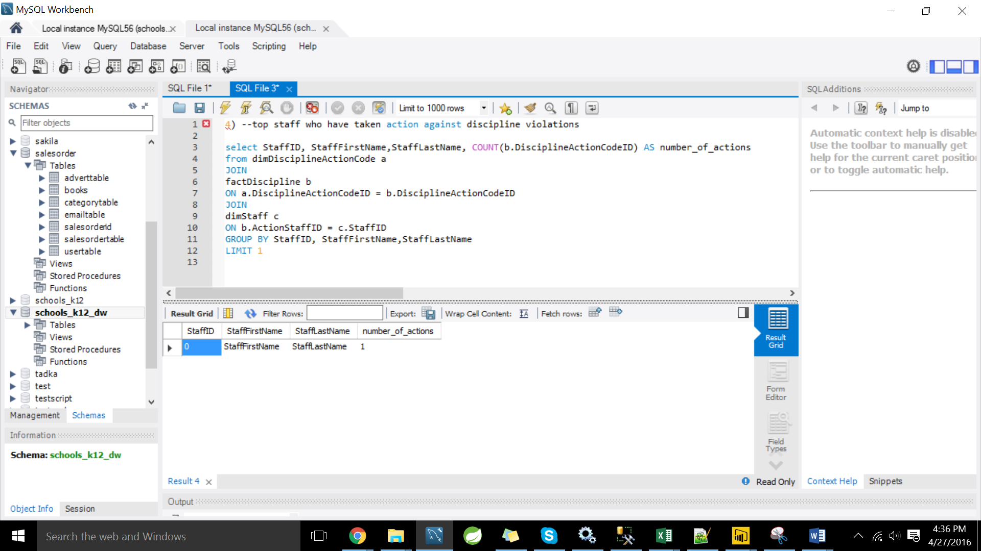

**5)--How did different ethnic groups varying wrt DRESS CODE VIOLATIONS**

Select a.DisciplineEventCode,a.DisciplineEventDesc,c.Ethnicity, COUNT(distinct b.StudentID) AS Student_Count

from

(Select a.DisciplineEventCode, DisciplineEventCodeID,a.DisciplineEventDesc

from dimDisciplineEventCode a

where a.DisciplineEventCode='N12'

)a

JOIN

factDiscipline b

ON a.DisciplineEventCodeID = b.DisciplineEventCodeID

JOIN

dimStudent c

ON b.StudentID = c.StudentID

GROUP BY a.DisciplineEventCode,a.DisciplineEventDesc,c.Ethnicity

ORDER BY COUNT(distinct b.StudentID) desc

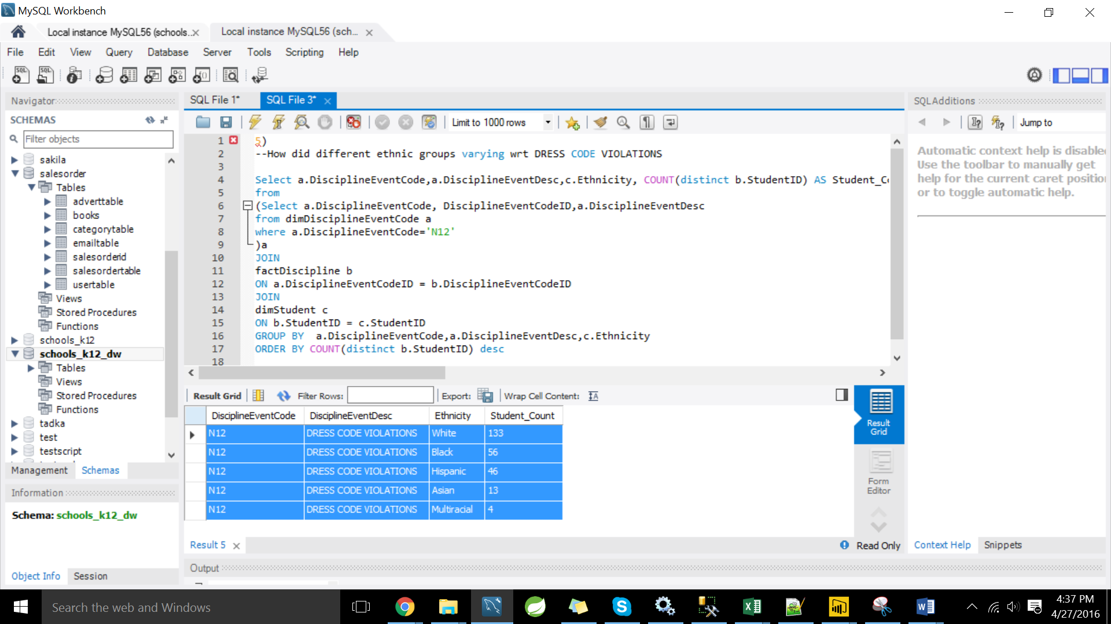

**6)-- How is grade distribute amongst the students who violate dresscode**

Select a.DisciplineEventCode,a.DisciplineEventDesc,c.Grade, COUNT(distinct b.StudentID) AS Student_Count

from

(Select a.DisciplineEventCode, DisciplineEventCodeID,a.DisciplineEventDesc

from dimDisciplineEventCode a

where a.DisciplineEventCode='N12'

)a

JOIN

factDiscipline b

ON a.DisciplineEventCodeID = b.DisciplineEventCodeID

JOIN

dimStudent c

ON b.StudentID = c.StudentID

GROUP BY a.DisciplineEventCode,a.DisciplineEventDesc,c.Grade

ORDER BY COUNT(distinct b.StudentID) desc;

**OUTPUT**

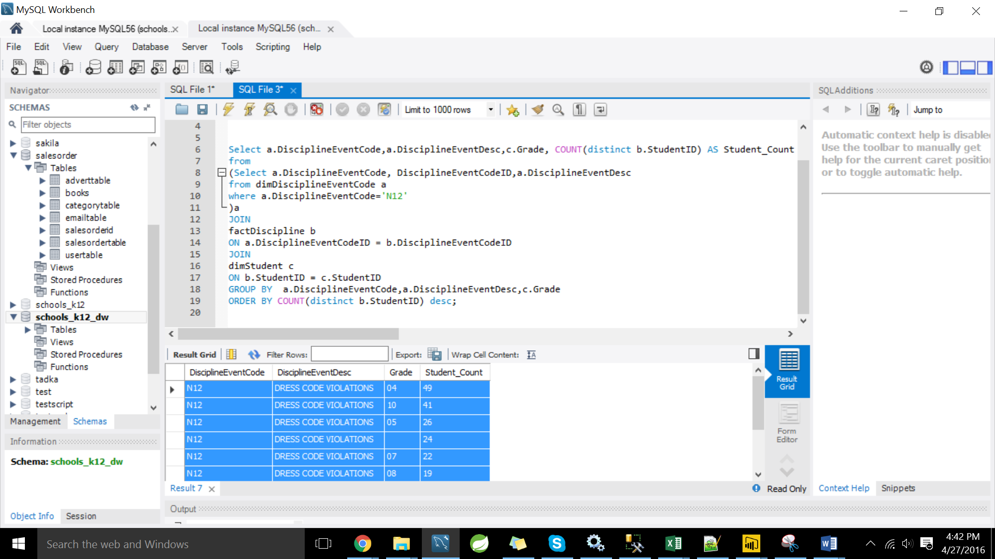

**7)--Which city has the highest number of discipline violating students**

Select a.DisciplineEventCode,a.DisciplineEventDesc,c.State, COUNT(distinct b.StudentID) AS Student_Count

from dimDisciplineEventCode a

JOIN

factDiscipline b

ON a.DisciplineEventCodeID = b.DisciplineEventCodeID

JOIN

dimStudent c

ON b.StudentID = c.StudentID

GROUP BY a.DisciplineEventCode,a.DisciplineEventDesc,c.State

ORDER BY COUNT(distinct b.StudentID) desc;

**OUTPUT**

